TRIARCHY PRESS - Press Release
TITLE | Small Arcs of Larger Circles
SUBTITLE | Framing through other patterns
AUTHOR | Nora Bateson
PAPERBACK:  9781909470965 | Price: £15/$20 | Size:  234mm x156mm | Format:  Paperback 210pp. | Publication Date:  30th September 2016
This is a wonderful first collection of essays, reflections and poems by Nora Bateson, the noted research designer, film-maker, writer and lecturer. She is the daughter of Gregory Bateson, president of the International Bateson Institute (IBI) and an adviser to numerous bodies at international and governmental level.

ABOUT THE BOOK
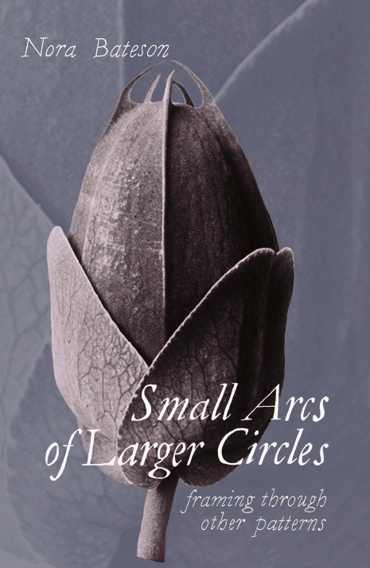
Building on Gregory Bateson’s famous book Towards an Ecology of Mind and her own film on the subject, Nora Bateson here updates our thinking on systems, ecosystems and complexity, applying her own insights and those of her team at IBI to education, families, organizations, justice, environmentalism, academia, and the whole way that society organizes itself.

She also introduces two terms:
- ‘symmathesy’ to describe the contextual mutual learning through interaction that takes place in living entities at larger or smaller scales
- ‘transcontextuality’ to describe the multiple, interlayered spatial, social, temporal, cultural, ecological, economic contexts in which symmathesy takes place.

While she retains her father’s rigorous attention to definition, observation and academic precision, she also moves well beyond that frame of reference to incorporate more embodied ways of knowing and understanding. These are reflected in her essays and poems on food, Christmas, love, honesty, environmentalism and leadership.

The book offers important advice and new thinking on issues like immigration, systems thinking, new economic and financial models, future thinking and strategic planning, sustainability and governmental ethics, agency in organizational leadership, the education system and organizational governance.

PARTIAL CONTENTS
If you knew me well you would know that I would give you everything ~ (inter) Facing An Ecology of Mind…
What do we value? ~ Mental mon-cropping ~ Nourishment ~ Symmathesy ~ Knowledge and complexity
Framing the symmetry ~ Non-Trivial Economy ~ An Ecology of Hurt ~ Parts and Wholes ~ Map to the trees ~ Policy for governance in the future.

KEYWORDS
Systems thinking, education, social anthropology, environmentalism, Bateson, symmathesy, inter-learning, knowledge, not-knowing.
CONTEXT
This collection is an intergenerational exploration of ideas within a family whose concern for the delicate interdependencies of life at all levels has inspired an ongoing intellectual, artistic, and intimate inquiry:
Nora Bateson’s grandfather, William, was Professor of Biology at Cambridge University and proposed the term ‘genetics’ in 1906.
Her father, Gregory, is known around the world as a ground-breaking anthropologist, philosopher, systems thinker, and cyberneticist.
And sure enough, the voice of the next generation is here too—with the Foreword written by the author’s daughter, Sahra Bateson Brubeck.
EARLY REVIEWS
“The way we see affects what we do,” writes Nora Bateson near the start of this exploratory, far-ranging foray into “unauthorized knowledge.” In a series of premise-investigations undertaken by way of essays, conference talks, autobiographical story, quotes and poems, ranging through linguistics, biology, semantics, cognitive theory, justice awareness and embrace of paradox, Bateson invites and advocates suppleness of perception, rigor of mind, and depth of feeling. In this book that moves above all by its questions, Bateson embodies that rarity, a truly free thinker also fully engaged with the fates of all."
Jane Hirshfield, Chancellor of The Academy of American Poets and author of The Beauty and Ten Windows: How Great Poems Transform the World

"Small Arcs of Larger Circles is a marvellous meditation of moving words making new pathways manifest in a lush and densely interconnected forest of ideas and experiences. Poetry, philosophy, and memoir merge in ecological thinking at its best."
​Professor Evan Thompson, University of British Columbia, author of Waking, Dreaming, Being and Mind in Life.
More information:
Triarchy Press
www.triarchypress.net ~ andrew@triarchypress.net

